**DAILY ONLINE ACTIVITIES SUMMARY**

|  |  |  |  |  |  |  |  |  |
| --- | --- | --- | --- | --- | --- | --- | --- | --- |
| **Date:** | **09/07/2020** | | | | | **Name:** | **NAIPUNYA VINOD NAIK** | |
| **Sem & Sec** | **IV SEM & A SECTION** | | | | | **USN:** | **4AL18CS050** | |
| **Online Test Summary** | | | | | | | | |
| **Subject** | | **NO INTERNALS CONDUCTED** | | | | | | |
| **Max. Marks** | | **30** | | **Score** | | | **---------------------** | |
| **Certification Course Summary** | | | | | | | | |
| **Course** | 1. **WEBINAR ON C++ PROGRAMMING** 2. **PYTHON PROGRAMMING WITH DATA SCIENCE** | | | | | | | |
| **Certificate Provider** | | | **1)AIET**  **2)UDEMY** | | **Duration** | | | **1) 1 HR 15 MIN**  **2) 15 HR** |
| **Coding Challenges** | | | | | | | | |
| **Problem Statement: NO PROBLEM STATEMENT GIVEN TODAY** | | | | | | | | |
| **Status: --------------------------** | | | | | | | | |
| **Uploaded the report in Github** | | | | | **YES** | | | |
| **If yes Repository name** | | | | | <https://github.com/naipunya-naik/daily-progress-report> | | | |
| **Uploaded the report in slack** | | | | | **YES** | | | |

Online Test Details: (Attach the snapshot and briefly write the report for the same).

NO INTERNALS CONDUCTED

Certification Course Details: (Attach the snapshot and briefly write the report for the same).

1. WEBINAR ON C++ PROGRAMMING

* CONDUCTED BY:-MS. SHRUTHI SHETTY J,ASST.PROF,CSE DEPT
* DURATION :- 1 HR 15 MIN
* FROM 9.30 AM TO 10.45 AM
* TOPICS COVERED INHERITANCE, POLYMORPHISM, FUNCTION OVERLOADING ETC.

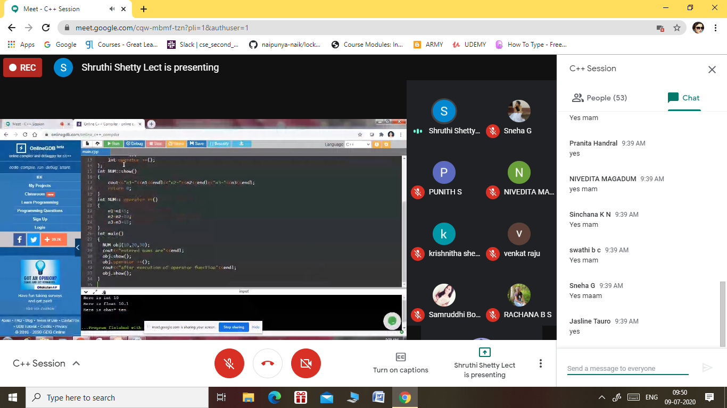

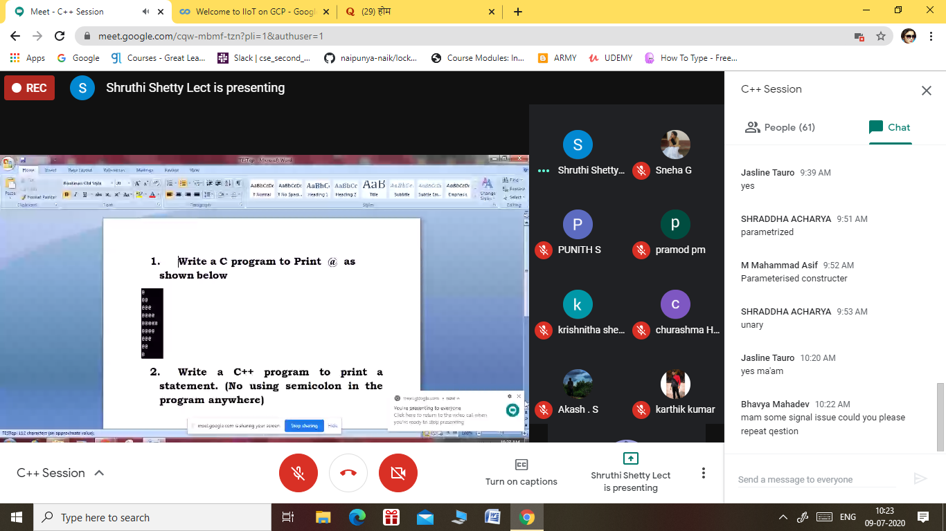

1. PYTHON PROGRAMMING WITH DATA SCIENCE

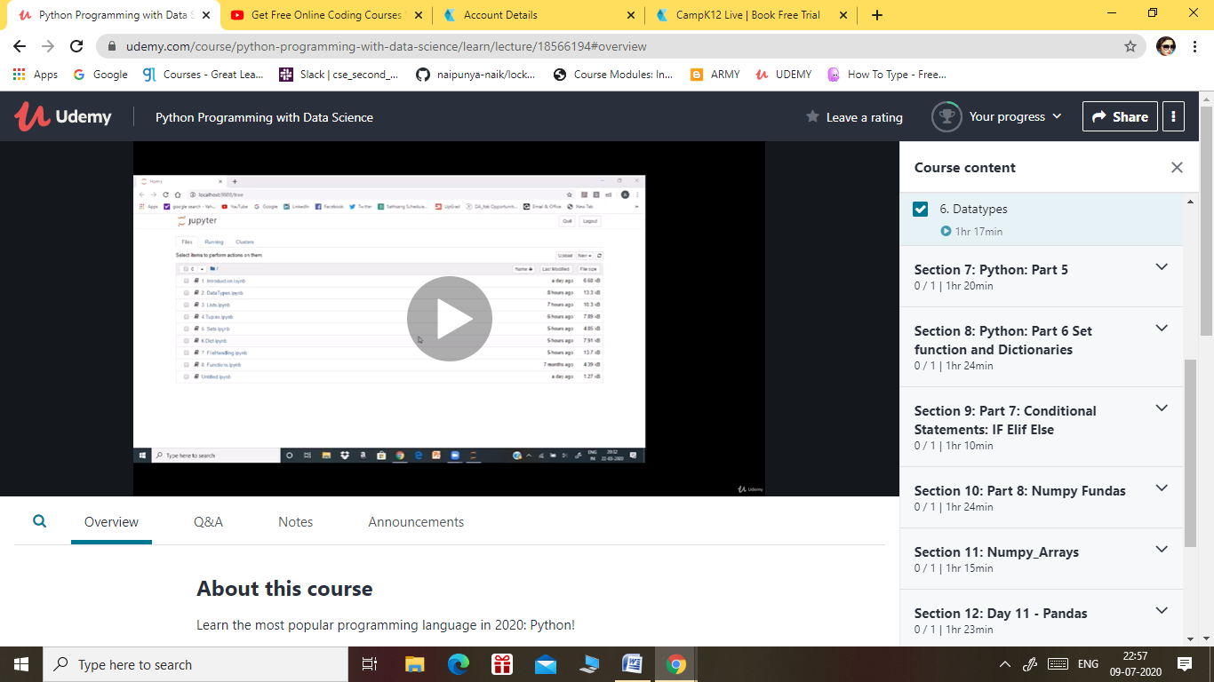

TOPICS LEARNT ON 09 JULY 2020:-

**Section 1: Welcome to Python**

**Section 2: Introduction**

**Section 3: Intro Continued**

**Section 4: Python: Part 2**

**Section 5: Python: Part 3**

**Section 6: Python: Part 4**

**Section 7: Python: Part 5**

Coding Challenges Details: (Attach the snapshot and briefly write the report for the same).

NO PROBLEM STATEMENT GIVEN TODAY